Luxembourg Development Indicators Modeling
Done by Tudor Sclifos, IS-251M

1. Introduction
This report builds upon the exploratory data analysis of Luxembourg's macroeconomic indicators. The previous analysis revealed Luxembourg's unique economic characteristics as a small, highly open economy integrated into European markets. Key findings included paradoxical positive GDP-unemployment correlations suggesting "jobless growth" patterns, well-anchored inflation driven primarily by external factors, and significant migration dynamics where population grew 2.14x through sustained immigration flows.
Building on these insights, this assignment develops predictive econometric models for three key macroeconomic variables: GDP growth rate, inflation rate, and unemployment rate. The modeling approach emphasizes theoretical grounding in established economic frameworks including Okun's Law, Phillips Curve relationships, and aggregate demand theory, while accounting for Luxembourg-specific dynamics observed during the EDA phase.
The analysis employs four distinct modeling approaches—Multiple Linear Regression, Polynomial Regression, HP-Filtered Regression, and ARIMAX—to capture different aspects of economic dynamics. All models use lagged predictors (t-1, t-4) to ensure realistic forecasting scenarios where only historical data is available at prediction time. The dataset spans 2000 Q2 to 2025 Q3 (103 observations after cleaning), split into training (2000-2021, 88 observations) and testing periods (2022-2025, 15 observations).

2. Data and Methods

2.1 Variable Selection and Feature Engineering
The analysis focuses on three target variables: GDP Growth Rate (quarterly, percentage), Inflation Rate (year-over-year consumer price changes), and Unemployment Rate (labor market health indicator). Feature selection was guided by economic theory and EDA findings, with VIF analysis revealing severe multicollinearity that necessitated reducing 53 engineered features to just 2-3 predictors per model. This constraint proved beneficial—with only 88 training observations, parsimonious models reduce overfitting and improve generalization.

2.2 Model Selection and Evaluation
Four complementary modeling approaches were implemented: Multiple Linear Regression (interpretable baseline), Polynomial Regression (degree 2, for non-linear dynamics), HP-Filtered Regression (λ=1600, for cyclical decomposition), and ARIMAX(1,0,1)×(0,0,1,4) (for temporal dependencies). The dataset was split chronologically with training from 2000 Q2-2021 Q4 (88 obs) and testing from 2022 Q1-2025 Q3 (15 obs). Performance is assessed using R², RMSE, and MAE metrics on both training and test sets.

3. Results

3.1 GDP Growth Forecasting
ARIMAX emerged as the best performer for GDP growth prediction, achieving Test R² = 0.81 and Test RMSE = 2.69 percentage points. The baseline Linear Regression performed competitively (Test R² = 0.80), while Polynomial Regression showed overfitting (Test R² dropped to 0.72). Coefficient interpretation reveals GDP growth is dominated by quarterly momentum (gdp_growth_lag4 = 0.84), with inflation showing weak negative effects and short-term dynamics being negligible.
Model | Train R² | Test R² | Test RMSE | Test MAE
Linear | 0.79 | 0.80 | 2.79 | 2.35
Polynomial | 0.80 | 0.72 | 3.25 | 2.85
HP Filter | 0.80 | 0.78 | 2.91 | 2.34
ARIMAX | 0.84 | 0.81 | 2.69 | 2.17
Table 1: GDP Growth Model Performance
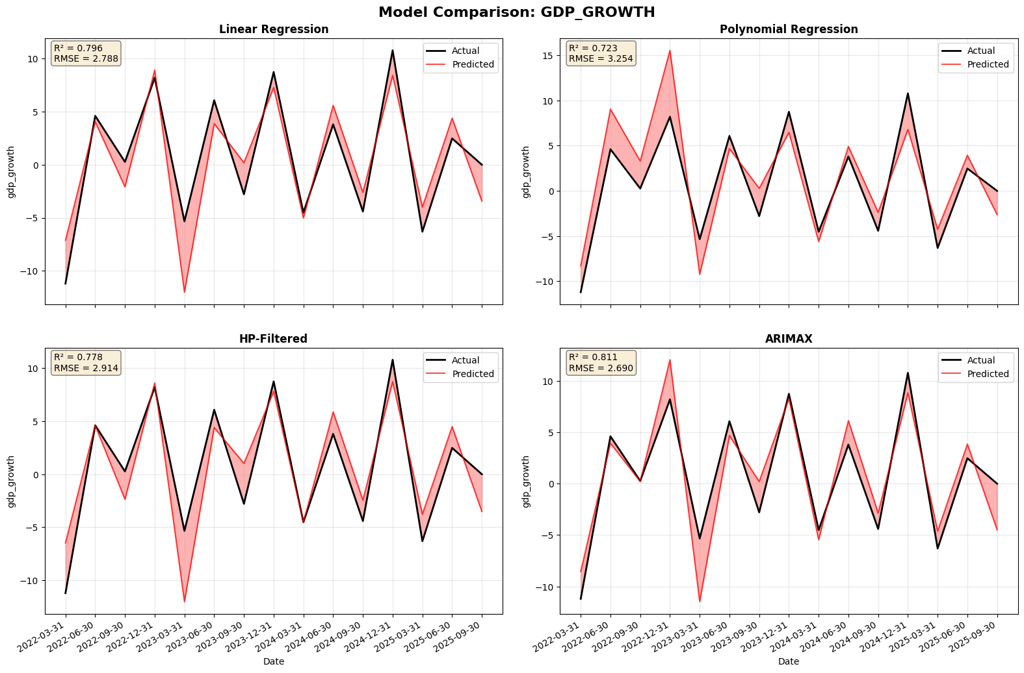
Figure 1: Actual vs Predicted GDP Growth across All Models

3.2 Inflation Forecasting
HP-Filtered Regression dramatically outperformed other approaches, achieving Test R² = 0.76 compared to negative R² values for Linear and Polynomial models. This suggests inflation dynamics are fundamentally cyclical rather than linearly related to GDP and past inflation. The baseline models' failure confirms EDA findings that Luxembourg's inflation has weak correlations with domestic variables and is better explained by business cycle patterns and external price shocks.
Model | Train R² | Test R² | Test RMSE | Test MAE
Linear | 0.01 | -0.43 | 3.17 | 2.04
Polynomial | 0.08 | -1.13 | 3.87 | 2.86
HP Filter | 0.41 | 0.76 | 1.29 | 1.09
ARIMAX | 0.23 | 0.23 | 2.32 | 1.74
Table 2: Inflation Model Performance

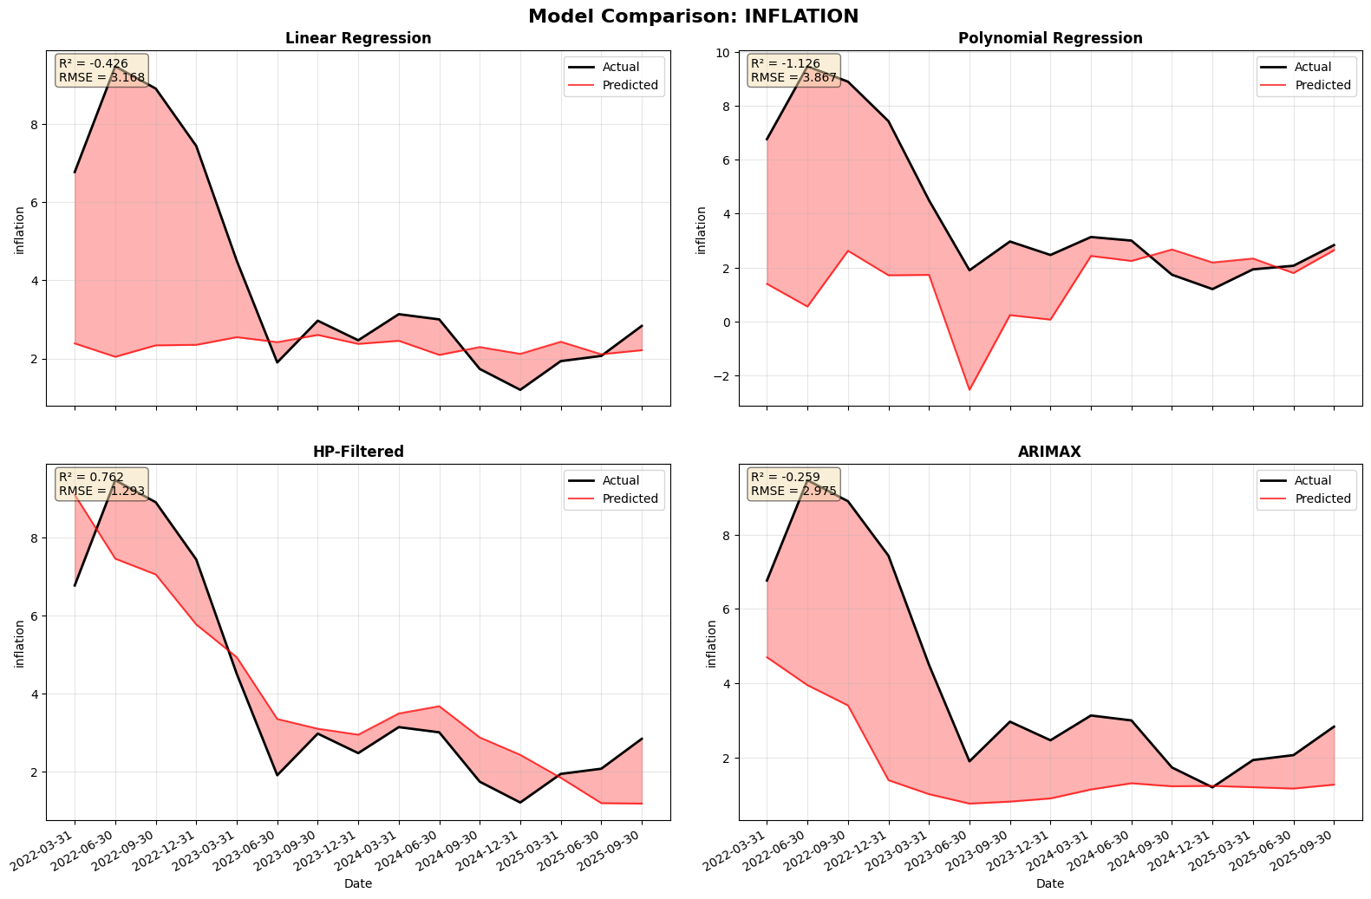
Figure 2: Actual vs Predicted Inflation across All Models

3.3 Unemployment Forecasting
HP-Filtered Regression achieved exceptional performance with Test R² = 0.88 and Test RMSE = 0.29 percentage points—by far the strongest predictive accuracy across all targets. The dramatic contrast with other models' failures (negative test R²) highlights unemployment's fundamentally cyclical nature. Linear and Polynomial models cannot capture dynamics, while ARIMAX showed severe overfitting despite strong training performance (Train R² = 0.91 vs Test R² = -3.59).
Model | Train R² | Test R² | Test RMSE | Test MAE
Linear | 0.23 | -3.58 | 1.79 | 1.65
Polynomial | 0.34 | -4.37 | 1.94 | 1.79
HP Filter | 0.87 | 0.88 | 0.29 | 0.23
ARIMAX | 0.91 | -3.59 | 1.79 | 1.49
Table 3: Unemployment Model Performance

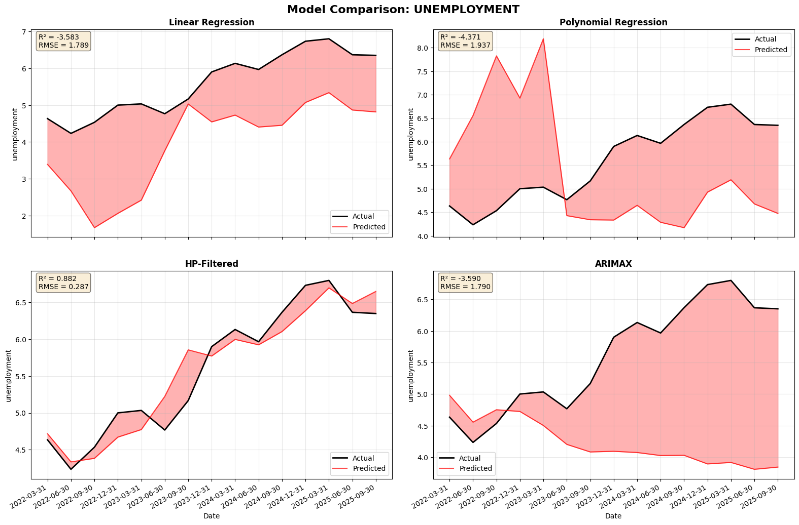
Figure 3: Actual vs Predicted Unemployment across All Models

3.4 Residual Analysis
Comprehensive residual diagnostics were performed on the best-performing models. GDP Growth ARIMAX residuals pass all tests: normality confirmed (Shapiro-Wilk p=0.97, near-zero skewness), constant variance verified (weak 0.02 correlation), and independence satisfied (Durbin-Watson=1.95). Inflation and Unemployment HP-Filtered residuals show minor autocorrelation (DW=0.48 and 0.55) despite passing normality and homoscedasticity tests, indicating cyclical persistence not fully captured but with strong prediction accuracy maintained.
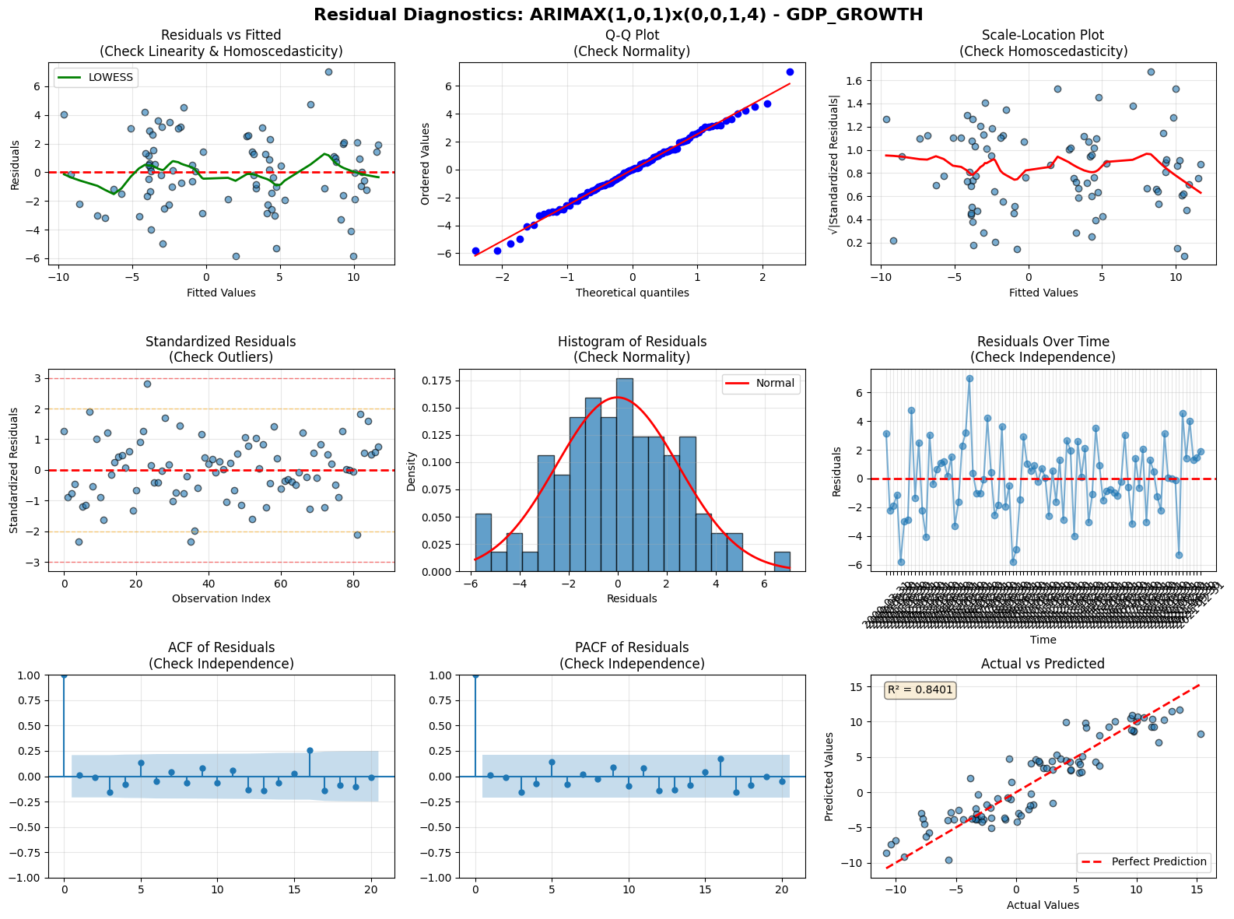
Figure 4: Residual Diagnostics for ARIMAX GDP Growth Model

4. Discussion

4.1 Key Findings and Implications
The modeling exercise successfully demonstrates that different economic variables require fundamentally different approaches. GDP growth benefits from time series methods capturing autoregressive properties (ARIMAX Test R² = 0.81), while inflation and unemployment require cyclical decomposition (HP Filter Test R² = 0.76 and 0.88 respectively). The parsimonious 2-3 predictor specifications proved optimal given 88 training observations, with Polynomial and ARIMAX overfitting examples illustrating that complexity must be calibrated to sample size.
Results validate EDA insights: Luxembourg's inflation is weakly linked to domestic variables and better explained by cycles than GDP relationships; unemployment-GDP dynamics remain paradoxical with linear models failing while cyclical methods succeed, confirming Okun's Law breakdown in this unique labor market. The use of lagged predictors ensures realistic forecasting applicable to practical policy scenarios.

4.2 Limitations and Future Improvements
Limited sample size (88 training observations) constrains model complexity, while detected autocorrelation in HP-Filtered residuals suggests incomplete cyclical capture. Performance during structural breaks remains uncertain—models may struggle with regime changes despite training on 2008 and COVID crises. Luxembourg-specific patterns may not generalize to other economies.
Potential improvements include: incorporating Luxembourg-specific variables (cross-border flows, financial sector indicators), ensemble methods combining model strengths, regime-switching specifications for crisis periods, and refitting with larger samples as post-2025 data accumulates to strengthen generalization and enable more complex specifications.

5. Conclusion
This analysis successfully developed predictive econometric models for Luxembourg's key macroeconomic indicators, achieving strong out-of-sample performance through parsimonious, theoretically grounded specifications. ARIMAX excels for GDP growth (Test R² = 0.81), while HP-Filtered regression dominates for inflation (Test R² = 0.76) and unemployment (Test R² = 0.88), demonstrating that different variables require fundamentally different modeling approaches.
The constraint of 88 training observations proved instructive, forcing disciplined feature selection and demonstrating that simpler models often outperform complex alternatives. Results validate EDA insights about Luxembourg's unique economic patterns while providing actionable forecasting tools with clear accuracy bounds: GDP growth predictions have ±2.7pp typical errors, inflation ±1.3pp, and unemployment achieves remarkable ±0.3pp precision.
From a policy perspective, these error magnitudes inform appropriate model applications—GDP forecasts provide directional guidance while unemployment predictions can support precise policy targeting. The models establish a solid benchmark for macroeconomic forecasting in small, open European economies, with identified improvements offering clear pathways for future research as additional post-2025 data enables longer-run performance assessment and more robust generalization testing.

